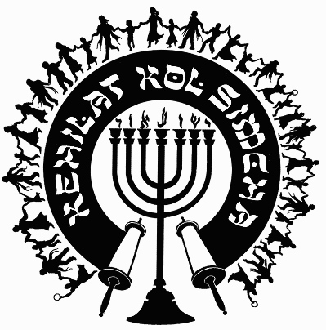
Kehilat
Kol Simcha
2925 NW 39th Ave.
Gainesville, FL 32605
(352) 485-1210
{P.O. Box 358924
Gainesville, FL 32635-8924}
“Kol Sason V’Kol Simcha, Kol Chatan V’Kol Kala”
“The voice of joy, and the voice of gladness, the voice of the bridegroom, and the voice of the bride…” (Jer. 33:11)
A family-oriented congregation of Jewish and Gentile believers who worship Israel’s Messiah, Y’shua HaMashiac (Jesus Christ), in the context of Jewish lifestyle and identity. We are committed to restoring the family unit and the Biblical/Jewish roots of our faith in the God of Abraham, Isaac and Jacob. Come share the joy!

February 10, 2024

5785-5786 (2025) High Holiday Services Schedule
(All Times are Tentative at Best… See Website for last minute changes)

Purim
Erev Purim Thursday February 13, 2025, at ~6:30pm (after sunset) Main Sanctuary

Pesach / Feast of Matzot (Passover, Lev. 23:4-14)
14th Aviv Fri. Evening April 11, 2025, at 7:00pm (sunset 7, Kol Simcha’s Yeshua Passover Seder) Gymnasium
14th Aviv Day Sat. April 12, 2025, Shabbat Service at 10:00am in the Main Sanctuary
15th Aviv Eve Sat. Night 12Apr25, Feast of Unleavened Bread, 6pm, Main Sanctuary (Home Seder after service)
15th Aviv Day Sun. April 13, 2025, 15th Aviv First Day of Unleavened Bread, No Service
21st Aviv Eve Friday April 18, 2025, Main Sanctuary – (sundown) TBA
21st Aviv Day Sat. April 19, 2025, 10a Main Sanctuary

Shavuot (Pentecost, Lev. 23:15-22)
Kol Simcha Shavuot Service & Picnic Sunday June 8, 2025 @ 9am at Poe Springs

Rosh Hashanah (Feast of Trumpets, Yom Teruah, Lev. 23:24)
Monday Evening September 22, 2025, at 7:30pm (after sunset, Sweets Oneg) Main Sanctuary
Tuesday Morning September 23, 2025, at 10am (Full Oneg) Main Sanctuary

Yom Kippur ( Day of Atonement, Lev. 23:27)
Wednesday Evening October 1, 2025, at 7:00pm (after sunset) Main Sanctuary
Thursday Morning October 2, 2025, at 12pm (Noon, “break-fast” TBA at sunset) Main Sanctuary

Sukkot (Feast of Tabernacles, Lev. 23:34)
1st Day
Monday Evening October 6, 2025, at 7:30pm (in the Sukkah Service) Pavilion
Tuesday Morning October 7, 2025, at 10am (Full Oneg in Sukkah) Main Sanctuary

8th Day - Shemini Atzeret / Simchat Torah
Monday Evening October 13, 2025, service TBA
Tuesday Morning October 14, 2025, at 10am (Full Oneg) Main Sanctuary

Chanukah
First Night Sunday Night December 14, 2025, at sunset, No Service
Eight Night Sunday Night December 21, 2025, at 5:30pm, KS Chanukah Party in the Kids Building

Rabbi A. Antonio Arroyo

